**Question 1:**

1. To derive the truncation error for the center difference formula, we first have to derive the Taylor expansion for f(x + h) and f(x - h):

$$f\left(x+h\right)=f\left(x\right)+f^{'}\left(x\right)h+\frac{f^{''}(x)h^{2}}{2}+\frac{f^{'''}(θ)h^{3}}{6}$$

$$f\left(x-h\right)=f\left(x\right)-f^{'}\left(x\right)h+\frac{f^{''}\left(x\right)h^{2}}{2}-\frac{f^{'''}(φ)h^{3}}{6}$$

Where $θ∈[x, x+h]$ and $φ∈[x, x-h]$. Let N, M be the bounds of $|f^{'''}\left(θ\right)|$. and $|f^{'''}\left(φ\right)|$.

Then the above equation can be written as:

$$f\left(x+h\right)=f\left(x\right)+f^{'}\left(x\right)h+\frac{f^{''}(x)h^{2}}{2}+\frac{Nh^{3}}{6}$$

$$f\left(x-h\right)=f\left(x\right)-f^{'}\left(x\right)h+\frac{f^{''}\left(x\right)h^{2}}{2}-\frac{Mh^{3}}{6}$$

Then we calculate use this to calculate $f\left(x+h\right)- f\left(x-h\right)$:

$$f\left(x+h\right)- f\left(x-h\right)= 2f^{'}\left(x\right)h+\frac{Nh^{3}}{6}+\frac{Mh^{3}}{6}$$

$$f\left(x+h\right)- f\left(x-h\right)= 2f^{'}\left(x\right)h+\frac{(N+M{)h}^{3}}{6}$$

Therefore:

$$\frac{f\left(x+h\right)- f\left(x-h\right)}{2h}=f^{'}\left(x\right)+\frac{(N+M{)h}^{2}}{12}$$

The term $\frac{(N+M{)h}^{2}}{12}$ is the truncation error. Then the total error of central difference formula is:

$$\frac{(N+M{)h}^{2}}{12}+ \frac{ε}{h}$$

To minimize the truncation error, we will find the place where the total error’s derivitive is 0.

i.e, the solution of the equation below is the optimal value for h:

$$\frac{1}{6}\left(N+M\right)h- \frac{ε}{h^{2}}=0$$

Solve for h:

$$\frac{1}{6}\left(N+M\right)h= \frac{ε}{h^{2}}$$

$$h^{3}= \frac{6ε}{\left(N+M\right)}$$

$$h= \sqrt[3]{\frac{6ε}{\left(N+M\right)}}$$

Hence, we have found the value for h that minimize the total error as desired.

1. Please see a1-report.py for source code.
2. The graph produce by my code is presented below, the second graph shows added the theoretical lower bounds for truncate and rounding errors:

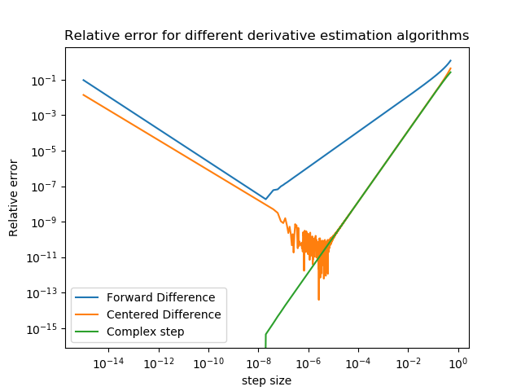

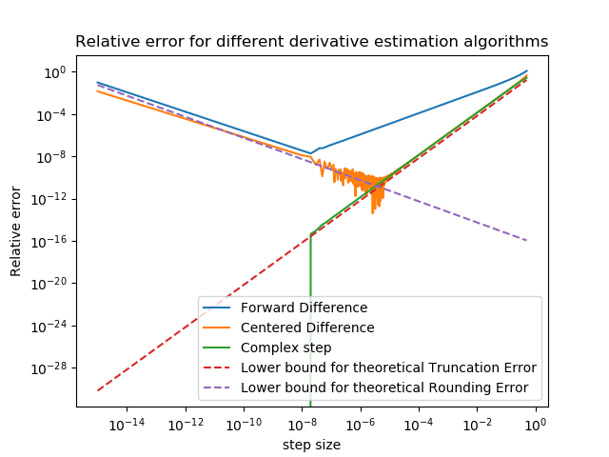

1. On the graph produced by my code, forward difference agree with the theoratical error value, since both of them have a error of order O(h). Note that the two theratical lower bounds are the analytic bounds for the centered diffenece algorithm. Compare to the lower bounds, it is obvious that forward difference generally produce more error than the centered difference method and the complex step method. The centered difference method agree with the analytic bound in part a) by following the given bounds. However, as the total error approaches towards its minium, it started to oscillate. This might be due to cancellation during the calculation process and numerical stability of the way I implement the centered difference methods. For complex methods, it stricly follows the O(h­2) truncation error lower bound for steps size greater that 10-7. However, when the step size is smaller than around 10-8, it suddenly drops to zero. This is likely due to the rounding issue. In my code I use numpy’s complex128 to carry out my calculation and it has a machine epsilon near 2e-16, which explain why the graph drops to zero below 1e-16.
2. One possiblity is that we could use other function to approximate the original function at the given point. We can use the taylor expansion of the function we use to approximate to estimate the error.